

**MAX INFRASTRUCTURE LIMITED**

**Ref: MIFL/SC/2024/10/02**

Tel : +88 02 55058345, 55058346

+88 02 223388646

Ip : +88 09614999333

Fax : +88 02 471J0176

Email : info@maxgroup-bd.com Web : [www.maxgroup-bd.com](http://www.maxgroup-bd.com/)

**Date: 02-10-2024**

**To Whom It May Concern**

This is to certify that, **MD. Abul Kalam Azad**, bearing ID: 100007589 is a permanent employee of Max Infrastructure Limited and working from 15th July 2019 to till date as **Assistant Manager**, **Internal Audit**. He draws **BDT 85,000/-** per month as net salary.

His Salary Structure per month is as follows:

Basic : 33,999 BDT

House Rent : 30,001 BDT

Medical : 8,000 BDT

Conveyance : 8,000 BDT

TA/DA : 5,000 BDT

________________________________________

Total Gross Salary : 85,000 BDT Only

We are issuing this letter on the request of our employee for banking purposes without accepting any liability on behalf of this letter or part of this letter on our organization

Sincerely Yours,

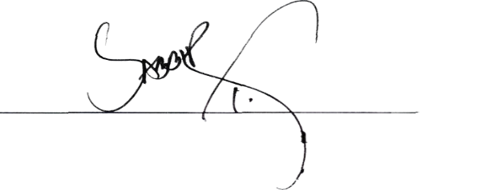



# **Sabbir Haider Taposh** Executive, Human Resources Contact: +880 1713 197847



**Corporate Office** : RAOWA Complex, Level-11,VIP Road, Mohakhali, Dhaka-1206, Bangladesh **Head Office** : Baitui Hossain Building (6th Floor), 27 Dilkusha Commercial Area, Dhaka-1000, Bangladesh